The Don Returns
Don is returning from Sicily. Create a spreadsheet showing everyone’s meal choices for Don Corblimeys return party.
- You need to copy this outline into a blank excel worksheet.
- Add some food/menu choices and their prices. Do some research on the internet (remember that Don doesn’t want to spend lots of money!)
- Sort these by course and then alphabetically, so all the Starters are together but also in alphabetical order.
- Create a drop down list for the food choices using data validation tools.
- Create a VLookup to display the choice cost.
- Add up the 3 costs to give the total for each person.
- Add up the grand total.
- If the grand total is greater than £150 you need to display “Too expensive for Don!!” if it is less then display “Nice work! Don will be happy”
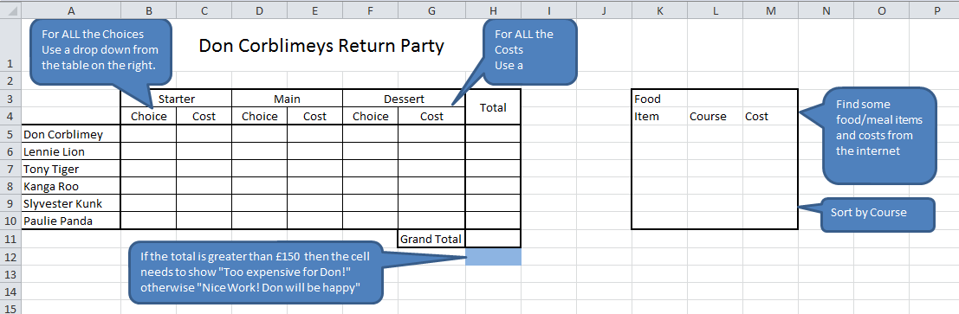
Ideas for extending this task:
- If statements showing whether the total meal cost is over £50.
- Conditional formatting showing the most and least expensive food choices
- Create a bar chart showing the people and how much their meals cost. Don’t forget chart & axis titles.

